Telecom Customer Churn Analysis Report
By Ayush Rawat

1. Executive Summary
Customer churn is a critical issue for telecom companies because retaining an existing customer is significantly cheaper than acquiring a new one. This project analyses a telecom customer dataset to identify behavioural and service-related factors influencing churn. Using Python for data preparation and Power BI for visualization, the analysis reveals that customers with short tenure, month-to-month contracts, higher monthly charges, and lack of technical support are significantly more likely to leave. The report concludes with data-driven recommendations aimed at improving customer retention and long-term profitability.

2. Problem Statement
Telecom companies face major financial loss when customers discontinue services. The organization needs to understand:
- Which customers are most likely to churn
- What factors influence churn behaviour
- What actions can reduce churn
The objective of this analysis is to identify churn drivers and recommend business strategies to improve customer retention.

3. Dataset Description
The dataset contains records of 7,043 customers with demographic details, service subscriptions, billing information, and churn status.
Feature | Description
tenure | Number of months the customer stayed
MonthlyCharges | Monthly subscription fee
TotalCharges | Total amount paid
Contract | Contract type (Month-to-month, One year, Two year)
InternetService | Internet type used
PaymentMethod | Mode of payment
TechSupport | Availability of tech support
OnlineSecurity | Security service subscription
Churn | Whether customer left (Yes/No)

4. Data Cleaning & Preparation
The dataset required preprocessing before analysis. The following steps were performed using Python:
- Converted TotalCharges from text to numeric
- Removed missing and invalid records
- Checked and removed duplicates
- Converted churn values into analyzable format
- Created tenure groups for lifecycle analysis
- Prepared dataset for Power BI visualization
This ensured accurate statistical and visual analysis.

5. Exploratory Data Analysis (EDA)

5.1 Overall Churn Rate
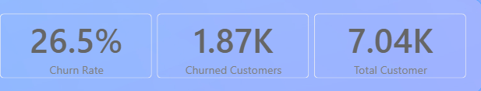
The overall churn rate is approximately 27%, indicating a significant customer attrition problem that requires intervention.

5.2 Churn by Contract Type
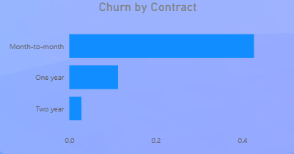
Customers with month-to-month contracts show the highest churn, while customers with long-term contracts rarely leave.

5.3 Churn by Tenure Group
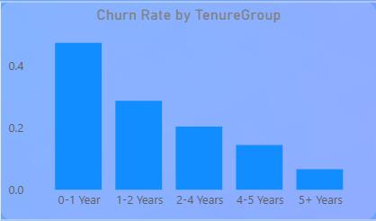
The analysis reveals that customers in their first year are most likely to leave, suggesting problems in early customer engagement and onboarding.

5.4 Internet Service vs Churn
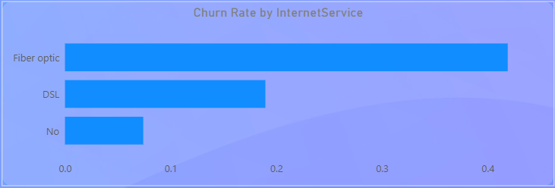
Fiber optic users exhibit higher churn, possibly due to higher pricing or service expectations.

5.5 Tech Support vs Churn
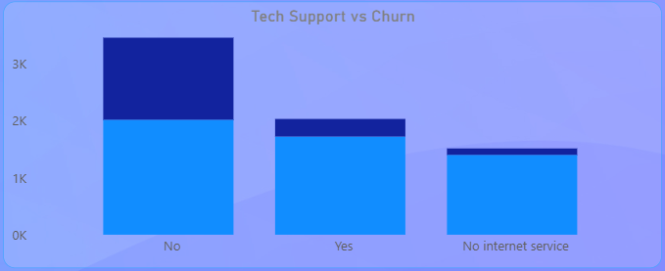
Customers without technical support services churn significantly more, indicating service assistance strongly influences retention.

5.6 Tenure vs Monthly Charges (Risk Segmentation Scatter Plot)
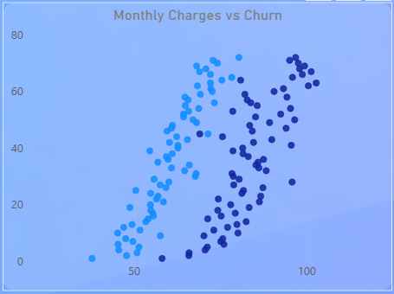
The scatter plot shows high-paying customers with low tenure are the most vulnerable segment.

5.7 Payment Method vs Churn
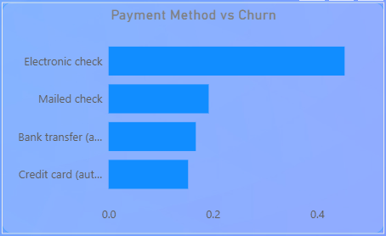
Customers paying via electronic check churn more frequently, suggesting payment friction contributes to attrition.

6. Key Findings
- Overall churn rate is approximately 27%
- New customers (first year) have the highest churn probability
- Month-to-month contracts are the primary churn driver
- High monthly charges increase churn likelihood
- Lack of tech support significantly increases churn
- Fiber optic customers show elevated churn rates
- Electronic check payment method correlates with higher churn

7. Business Recommendations
Based on the findings, the company should consider the following actions:
- Offer discounts or incentives for long-term contracts
- Improve onboarding experience during the first 90 days
- Provide free or discounted technical support initially
- Bundle online security and support services
- Encourage automatic payment methods
- Review pricing strategy for high-cost plans
These actions can reduce churn and improve customer lifetime value.

8. Limitations
- Dataset does not include customer satisfaction scores
- External factors such as competitor pricing are unknown
- No geographic competition analysis available
Future work may include predictive modelling using machine learning.

9. Conclusion
The analysis successfully identified major churn drivers related to customer lifecycle, pricing, and service support. The findings suggest that improving early customer engagement, offering long-term contract incentives, and enhancing service support can significantly reduce customer attrition. Implementing these strategies can improve customer retention, reduce acquisition costs, and increase long-term revenue.

10. Tools & Technologies Used
- Python (Pandas, NumPy)
- Data Cleaning & Transformation
- Exploratory Data Analysis
- Power BI Dashboarding
- Business Intelligence Reporting

End of Report

